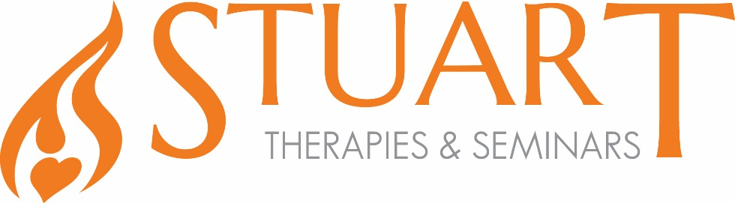
Fascial Approaches: Shoulder

The shoulder joint is the most flexible joint in the body. It is surrounded and influenced by over a dozen muscles which allow it the greatest ranges of motion possible of any joint of the body. When the integrity of this joint is affected by trauma, most of these muscles and their associated fascia will respond by creating excessive tensile forces to protect this area from any further harm. Upper trapezius and levator scapula muscles when they are stressed by physical, mental, and emotional trauma as well as posture can take on a seemingly solidified texture.

Join us in exploring how to assess and treat this area using fascial techniques and exercises to bring about release to the muscles and fascia of the shoulder region.

WHAT YOU WILL LEARN
- How to assess for shoulder imbalances
- Understanding the relationships that the muscles of the shoulder region have with each other and their role in the imbalance
- How to address the fascial tension of the anterior and posterior upper body
- Fascial treatment for specific musculature
- How to put an effective treatment plan together to treat the shoulder region and surrounding tissue
- Hands on techniques and practice to treat the shoulder region
- Stretches to isolate specific muscles and their coinciding fascia

Peter Stuart has been a massage therapist and educator since 1993, specializing in myofascial release within patient-centred therapy, treatment of chronic pain conditions, and transformation from the negative effects of trauma. He is co-founder and lead instructor for Stuart Therapies & Seminars Inc.

Dates: September 25 & 26;
Location: CCMH, Halifax, NS
Time: 9am - 5pm
CEUs: 7 MTANS; 14 Cat A PEIMTA; 7 Cat A CMTNL; 6.5 CMTNB
Investment: $475

To register, or for more information: peterstuart@me.com
902.452.4730

